THE MISSIONARY CHURCH
Acts 1:8; Mark 16: 15, 16; John 17:18-21; Acts 13:1-5

But ye shall receive power, after that the Holy Ghost is come upon you: and ye shall be witnesses unto me both in Jerusalem, and in all Judea, and in Samaria, and unto the uttermost part of the earth. (Acts 1:8)

And he said unto them, Go ye into all the world, and preach the gospel to every creature.

He that believeth and is baptized shall be saved; but he that believeth not shall be damned. (Mark 16:15, 16)

As thou hast sent me into the world, even so have I also sent them into the world.

And for their sakes I sanctify myself, that they also might be sanctified through the truth.

Neither pray I for these alone, but for them also which shall believe on me through their word;

That they all may be one; as thou, Father, art in me, and I in thee, that they also may be one in us: that the world may believe that thou hast sent me. (John 17:18-21)

Now there were in the church that was at Antioch certain prophets and teachers; as Barnabas, and Simeon that was called Niger, and Lucius of Cyrene, and Manaen, which had been brought up with Herod the tetrarch, and Saul.

As they ministered to the Lord, and fasted, the Holy Ghost said, Separate me Barnabas and Saul for the work whereunto I have called them.

And when they had fasted and prayed, and laid their hands on them, they sent them away.

So they, being sent forth by the Holy Ghost, departed unto Seleucia; and from thence they sailed to Cyprus.

And when they were at Salamis, they preached the word of God in the synagogues of the Jews: and they had also John to their minister. (Acts 13:1-5)

Chant: Glory be to the Father, and to the Son, and to the Holy Ghost as it was in the beginning, is now and ever shall be, world without end. Amen! Amen!

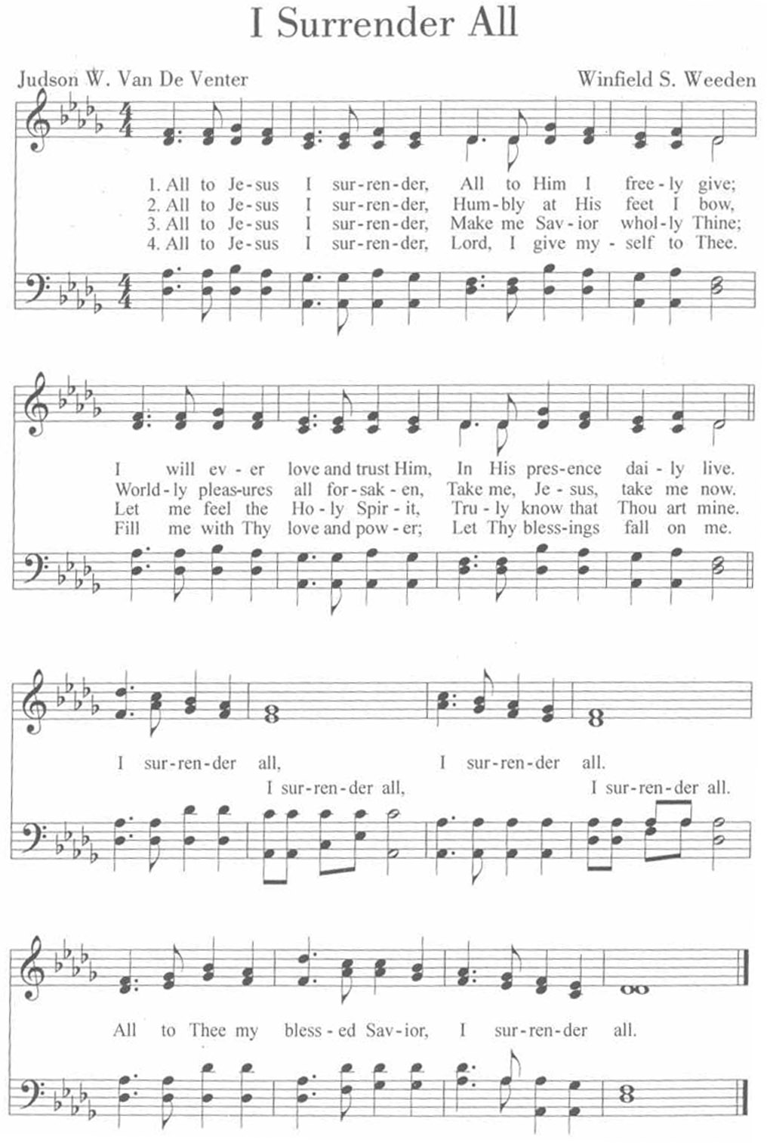
P R A Y E R L I S T
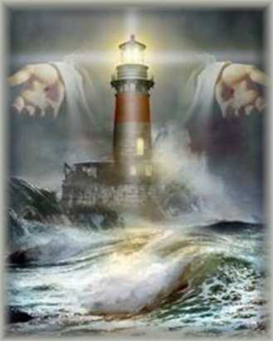

Sis. Sarah Albritton

Bro. Bryce Allen

Sis. LaWanda Allen & family

Sis. Sylvia Anderson

Sis Margaret & John Armstreet

Bro. Otis Aytch

The Burton Family

The Baines Family

Sis. Lula Baltrip

Sis. Marnita Aaron Bishop

Bro. Terry Blalock

Sis. Janet Brewster

Sis. Bernice Brown

Sis. Tyeshela Brown

Bro. Jonathan Brown

The Burley Family

Sis. Jessica Burton

Sis. Susan Burton

Sis. Cacie Chatman

Bro. William Chew

Sis. Carla Clark

Sis. Barbara Colon

Bro. Mard Davis

Bro. Elmer C. Dennis

Sis. Aurora Ador Dionsio

Sis. Maeola Dogan

Sis. Lawanda Dogan

The Doss Family

Sis. Jenny & Baby Ellison

Bro. Randy Ellison

Bro. Maurice Farris

Bro. Rylon Francis

Sis. Karen Freeman

The Freeman Family

Sis. Crystal Foley

Sis. Frankie Golden

Bro. Kenneth Hall

Bro. Marvin Hall

Sis. Hawa Harmon

Bro. Wesley Harvey
Sis. Mary Ann & Carrington Hinton

Bro. David Holden

Bro. Terry Jackson

Sis. Oda Mae James

The James Family

Bro. Fred & Sis. Renea Johnson

Sis. Ruth Johnson

Pastor J. Amos Jones & Sis. Odessa Jones

Rev. & Sis. James Jones

Bro. Terrence Jones

Bro. William Jones

Sis. DeAnn Kelly

Rev. & Sis. Adrian Lara

Bro. William Love & family

Sis. Doris Mack

The Magoun Family

Bro. Laray Malone

Rev. Elvis Mays

Bro. Virgil McAdams

Sis. Carol McCray

Sis. Diane McCully

Bro. Kevin McDonald

Bro. Serlett McKinley

Sis. Julia McKinney

Bro. Derrick McKinney

Bro. Scott McKinney

The Merchant Family (Bernice, Mary Lou, Kelvin, Kyle & Bernard)

Sis. Joyce Mitchell

The Monroy Family

Sis. Margie Moore

The Morgan Family

The Nelson Family

Bro. Carneal Nichols

Sis. Jennifer Okoro

Sis. Michelle Parker

Sis. Sadell Persons

Bro. Alex Rahn

Sis. Karla Simms

Sis. Gigi Smith

Sis. Lauryn Smith, Sis. Teaya Smith & The Smith Family

Sis. Ruby Taylor (Mother of Sis. Floriza Hubbard & Sis. Marie Taylor)

Bro. Charles Thomas

Bro. Harold Thomas

Sis. Brittney Thompkins

Sis. Peggy Townley

Sis NaKisha Viltz

Bro. James Walker

Bro. Jasper Walker

Bro. Maurice Ward

Sis. Pearline Weily

Sis. Amesha Williams

Sis. Shirley Williams

Sis. Ophelia Wooley

Sis. Youngblood

Bro. Martin Zedrick

FROM THE PASTOR’S DESK

August 31, 2014

Dear Ones, May I ask what is your PASSION? (capitalized for emphasis) Passion usually implies a strong emotion that has an overpowering or compellng effect i.e., extreme, compelling emotion; intense emotional drive or excitement.

For this Pastor, it is no secret; I have a passion for the lost, for souls, 2nd Peter 3:9 gives insight into the heart of God: “The Lord is not slack concerning His promise, as some men count slackness; but is longsuffering to us-ward. Not willing that any should perish, but that all should come to repentance”. Out of this passage of scripture is spawn this Pastor’s passion for the lost.

Number One, lost humanity being reconciled to Him is a passion of the Lord. In His desire that none should perish, God gave His only son, the righteous for the unrighteous.

Moreover, the Lord is extraordinarily patient with fallen humanity, we blow it bigtime and it is because of the Lord’s mercy and loving-kindness that we are not consumed. Praise God, His tender compassions fail not. You now know the Pastor’s passion, however, the question is, what is your passion?

Let me give you some “Food for Thought”: (1 John 2:15) “Love not the world neither the things that are in the world. If any man love the world, the love of the Father is not in him”. (The world, or realm of sin, which is controlled by Satan and organized against God and righteousness).

If your passion is not for God, His Kingdom, His righteousness or His will and purpose for your life, may I suggest that you subdue your passion and bring it into conformity with the will and desire of Almighty God. Hear and model the Apostle Paul: “But what things were gain to me, those I counted loss for Christ” (Philippians 1:7).

Be blessed as we continue in Him

Pastor J. Amos Jones

Weekly Calendar of August 31st – September 7th

Day of the Week | Date | Time | Event
Sunday | August 31, 2014 | 7:00PM | Evening Worship
Monday | September 1, 2014 | 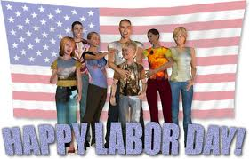
Tuesday | September 2, 2014 | 7:30PM | Support Group Meeting
Wednesday | September 3, 2014 | 7:00PM | Brotherhood Meeting  Senior Mission  Women-In-Action
Thursday | September 4, 2014 | 7:30PM | Prayer & Teachers’ Meeting
Friday | September 5, 2014 | 7:30PM | Bible Study  Praise Dancers’ Rehearsal
Sunday | September 7, 2014 | 7:00PM | Evening Worship

AUGUST NEWS

If you are in need of a Share Pot donation, please contact Sis. Maeola Dogan at (713) 433-6185 or Mmaeola@aol.com or Sis. Ethel Malone (281) 277-7539 or etha@windstream.net or Diana Lusk (713) 569-8449.

- Sunday, September 21st at 3:30PM – Friendship Missionary Baptist Church 74th Anniversary – Guest Oliver Chapel B.C. – Pastor, Donzell Archie

- 2014 FMBC Women's Conference – TBA

- Saturday, September 27, 2014 @ 7:30 pm. The 4th Annual FMBC Youth Explosion! Mark your calendars. Come out on this special night to celebrate God with your talent: singing, praise dance, gospel/Christian rap, Christian poetry, instrumental solos or whatever the Lord lays on your heart. Let us support our youth by coming out and having a good time in the Lord!

Please Do Not Walk During Invitation to Discipleship

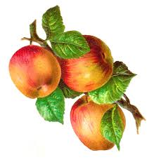
Happy Birthday FMBC Members Month of
August

Jeremiah Spikes August 2nd
Alexandria Spurlock August 4th
Willie Estel-La Dixon August 5th
Suntera Scott August 5th
Sheila Dixon August 7th
Lawanda Dogan August 7th
Shandra Burton August 9th
Timothy Anderson August 10th
Melissa Banks August 11th
Beverly Hurd August 13th
Kiara Smith August 14th
Grace Ferguson August 14th
Shelia Boyette August 17th
Ryan Brisco August 20th
Edward Dogan Jr. August 20th
Lisa Williams August 20th
James Cooper August 22nd
Craig Miller August 22nd
Maranda Oliver August 23rd
Vernon Rock August 25th
Deacon Edward Dogan August 25th
Vernon Rock August 25th
Flozia Hubbard August 26th
Claude Flack August 27th
Lance Lane August 27th
Hilda Arscott August 28th
Norris Jackson August 29th
Minister Vanessa Adderley August 30th
Hannah Davis August 30th
Shaneecia Martin August 31st

